- GREATEST OF THREE NUMBERS
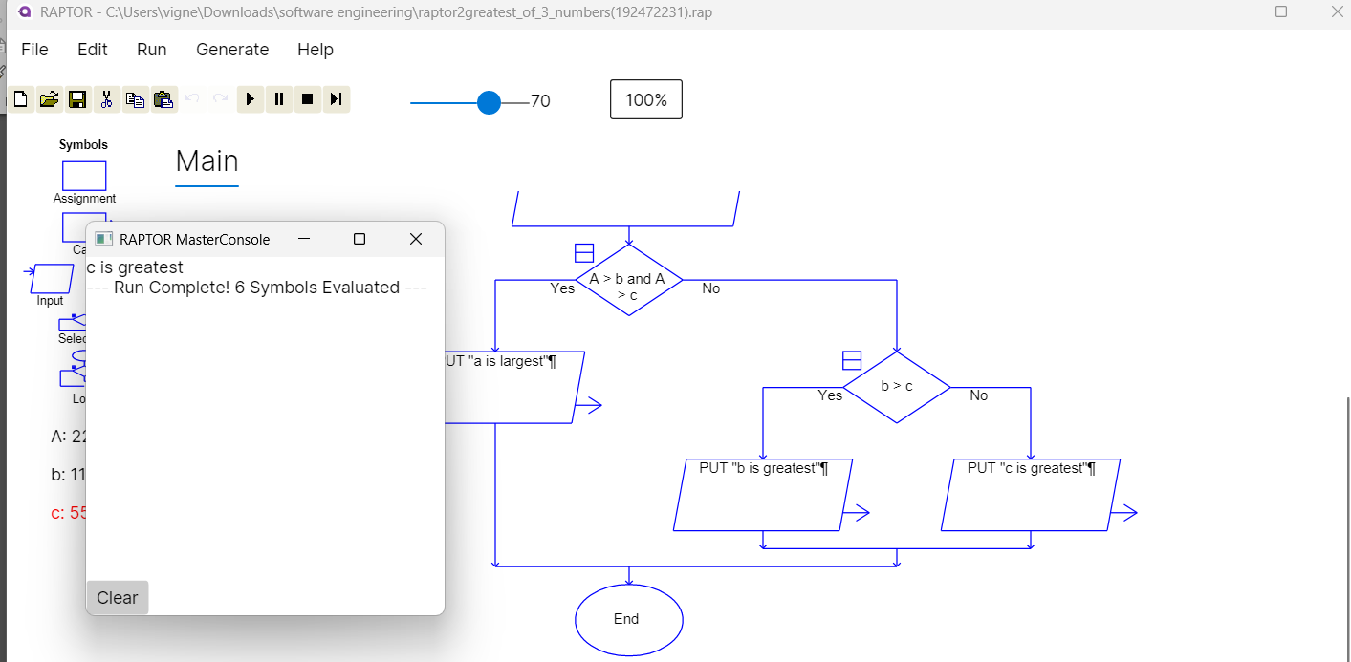
- ARMSTRONG NUMBER

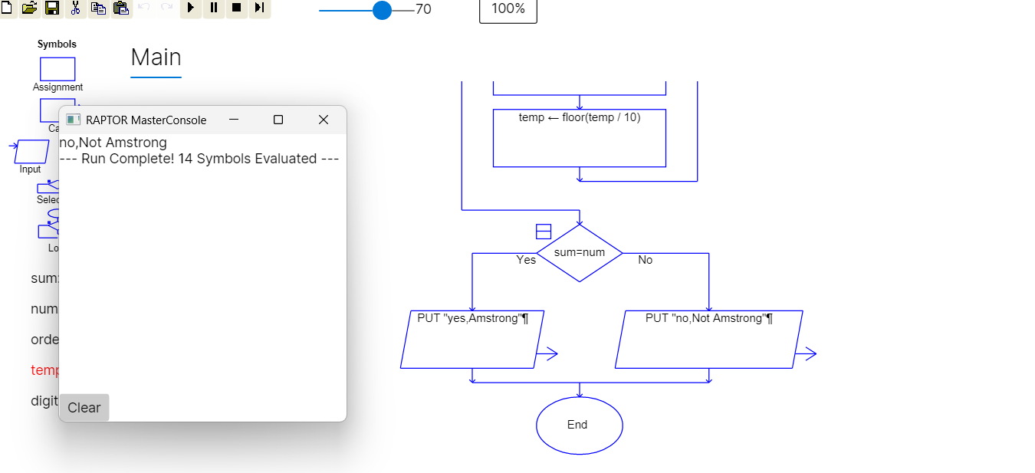

- FACTORIAL OF A NUMBER
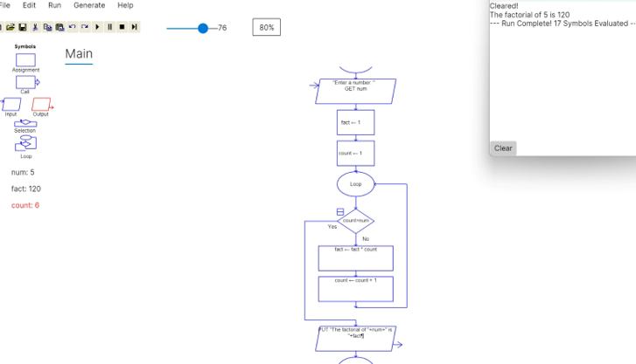

- NUMBER OF CHARACTERS IN A STRING
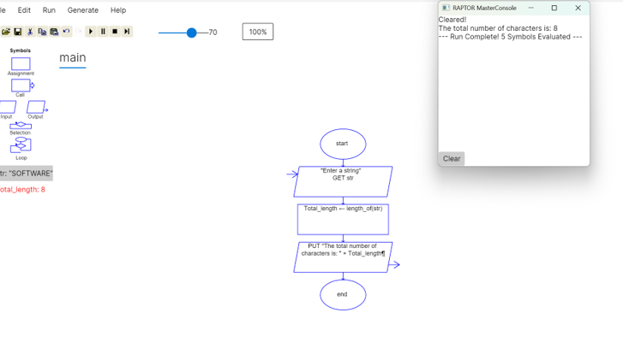

- LEXICOGRAPHICALLY SMALLEST STRING
